Data about the magazine:
Title | Annals of Pedagogies
Original title: | „Roczniki Pedagogiczne”
Frequency of publication: Quarterly | Quarterly
ISSN | 2080-850X
Distributed in its current form since | 2012
Domain | Education, training requirements, upbringing, Pedagogy
Country | Poland
Logo | 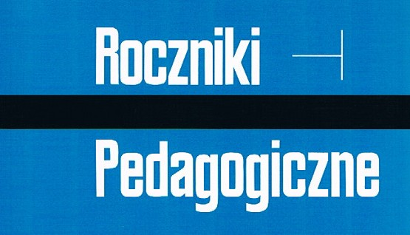
Brief description | Annals of Pedagogies (the continuation of "Annals of Social Sciences" published as No. 2: Pedagogics, from 1973), published since 2012 as a quarterly, is a pedagogical academic journal, which aims to publish current, original, empirical and theoretical research results in particular areas of the sciences on upbringing and promotes new and creative achievements in pedagogical methodology and methodology of educational work. The journal proposes articles in four areas of pedagogical research relevant to four issues devoted to: 1 / theory and the history of education and pedagogical thought; 2 / education and school pedagogy and didactics; 3 / special pedagogy, resocialization and preventive pedagogy, and psychopedagogy; 4 / pedagogy of caring, family pedagogy and social pedagogy.  The journal publishes scientific achievements of four types:  1 / original articles of both empirical and theoretical nature;  2 / reports and informative message texts;  3 / reviews;  4 / polemics, containing questions about the authors' texts as well as author’s answers and explanations  The Annals of Pedagogies apply objective criteria for the scientific evaluation of texts written by the authors. The journal is addressed to researchers and students in the above-mentioned pedagogical areas of theory and practice and representatives of related disciplines and fields of knowledge. There are also accepted texts in foreign languages, which are reviewed and evaluated by reviewers representing their original languages.

Additional information
Address | ul. Droga Męczenników Majdanka 70
City | Lublin
Post code | 20-325
Country | Poland
Telephone | (81) 475-93-19; +48/609754598
Fax | (81) 475-93-18; (81)532-20-83
e-mail | instped@kul.lublin.pl
Internet address | http://www.kul.pl/redakcje-naukowe,art_34092.html
Editor-in-Chief | Fr. Marian Nowak
Format | B5
Number of copies | 200
Annual premium amount
The average number of pages | 199

Data about the magazine:
Title: Annals of Pedagogies

Original title: Roczniki Pedagogiczne
Frequency of publication: Quarterly
ISSN 2080-850X
Distributed in its current form since 2012
Domain: Education, training requirements, upbringing, Pedagogy
Country Poland
Logo

Brief description: Annals of Pedagogies (the continuation of "Annals of Social Sciences" published as No. 2: Pedagogics, from 1973), published since 2012 as a quarterly, is a pedagogical academic journal, which aims to publish current, original, empirical and theoretical research results in particular areas of the sciences on upbringing and promotes new and creative achievements in pedagogical methodology and methodology of educational work. The journal proposes articles in four areas of pedagogical research relevant to four issues devoted to: 1 / theory and the history of education and pedagogical thought; 2 / education and school pedagogy and didactics; 3 / special pedagogy, resocialization and preventive pedagogy, and psychopedagogy; 4 / pedagogy of caring, family pedagogy and social pedagogy.
The journal publishes scientific achievements of four types:
1 / original articles of both empirical and theoretical nature;
2 / reports and informative message texts;
3 / reviews;
4 / polemics, containing questions about the authors' texts as well as author’s answers and explanations
The Annals of Pedagogies apply objective criteria for the scientific evaluation of texts written by the authors. The journal is addressed to researchers and students in the above-mentioned pedagogical areas of theory and practice and representatives of related disciplines and fields of knowledge. There are also accepted texts in foreign languages, which are reviewed and evaluated by reviewers representing their original languages.
Additional information
Address. ul. Droga Męczenników Majdanka 70
Lublin
Post code 20-325
Country Poland
Telephone (81) 475-93-19; 48/609754598
Fax (81) 475-93-18; (81) 532-20-83
E-mail instped@kul.lublin.pl
Internet address http://www.kul.pl/rednakcje-naukowe,art_34092.html
Editor-in-Chief Father Marian Nowak
B5 format
Number of copies 200
Annual premium amount
The average number of pages 199

