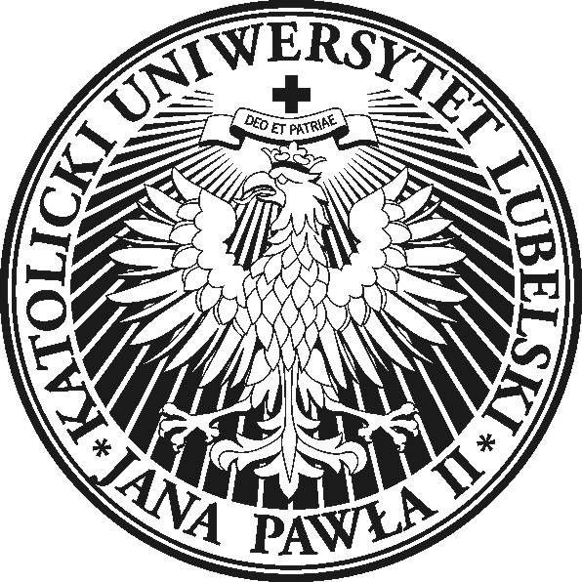
The John Paul II Catholic University of Lublin
Department of Celtic Studies


Call for papers

The Department of Celtic Studies at the Institute of English, The John Paul II Catholic University of Lublin invites submissions for the

1st Lublin Celtic Colloquium
New Trails and Beaten Paths in Celtic Studies

September 17-18, 2015
Lublin, Poland

Confirmed plenary speakers: Prof. Alan Titley, University College Cork
Prof. Sabine Asmus, University of Szczecin

Papers are invited in any of the following or related areas:
- Formal analysis of the Celtic languages from a synchronic and diachronic perspective
- Challenges in the teaching of the Celtic languages
- The future of the Celtic languages (sociolinguistics, contact linguistics and language planning)
- Issues of translation (the challenges of translating into and from languages of limited diffusion)
- Literary perceptions of Celtic traditions
- The history, literature and culture of the Celtic peoples

Please send an abstract of your paper proposal (200-300 words, including references) to celticcolloquium@gmail.com by 1st March 2015. The conference language is English. Your name and affiliation should be given in the e-mail message. Notification of acceptance will be given by 1st April 2015.
The conference fee is 300 PLN, and includes materials, coffee breaks and conference dinner. A selection of papers will be published in a post-conference volume.
Details concerning payment and accommodation options will be announced in the second circular.

Organising Committee:
Dr hab. Maria Bloch-Trojnar
Dr Robert Looby
Dr Mark Ó Fionnáin
Dr Aleksander Bednarski

