Central European Exchange Programme for University Studies (CEEPUS) has opened the call for applications in the frame of a new Programme CEEPUS for Ukraine.
Students, PhD students may apply for short-time studies and academic teachers for teaching internship to be carried out at Polish Universities. Applicants selected by the National CEEPUS Office will receive CEEPUS free mover grant.
Period of stay at Polish University:
Students: min. 3 months, max. 1 semester
PhD students: min. 1 month, max. 1 semester
Academic teachers: min. 5 working days (plus two days for trip: 1+5+1) , max 1 month - academic teachers are obliged to conduct 6 hours of teaching per week
Scholarship rates:
Students: Bachelor (1st cycle) student and uniform Master student 1-3 year - 1250 PLN, Master student (2nd cycle) and uniform Master student 4-6 year - 1500 PLN
PhD students: PhD student (3rd cycle) - 2200 PLN
Teacher with Master Degree - 2200 PLN
Teacher with PhD Degree - 3000 PLN
Application deadline: ongoing recruitment
Application process: the application process is carried out online. You need to register at CEEPUS website at first https://www.ceepus.info/login/login.aspx and then fill in the required data - please find attached the instruction.
During the process of application you will be asked to download:
1. Letter of Acceptance signed by the Host Institution (students and academic teachers download the Letter of Acceptance in the section/Downloads/ on personal CEEPUS account, after registration).
If you decide to apply for a grant at KUL please fill in the Letter of Acceptance. Your students, PhD students and academic teachers may either contact the host units here at KUL directly (institutes, departments) or through the agency of our International Relations Office - a contact person is Ms. Katarzyna Piwko (katarzyna.piwko@kul.pl, + 48 81 445 42 04).
2. Confirmation from your Home institution that you are a student/PhD student/academic teacher.
The website of CEEPUS Programme: https://www.ceepus.info/content/home
The website of KUL: https://www.kul.pl/kul,21.html
The list of courses in English at KUL (for students) : https://www.kul.pl/course-catalogue-2021-2022,art_17611.html
HOW TO REGISTER FOR A MOBILITY Application
For all CEEPUS applications: You have to register and create an account under My CEEPUS first.
Click on MY CEEPUS on the CEEPUS website www.ceepus.info

Click on “Click here to register”
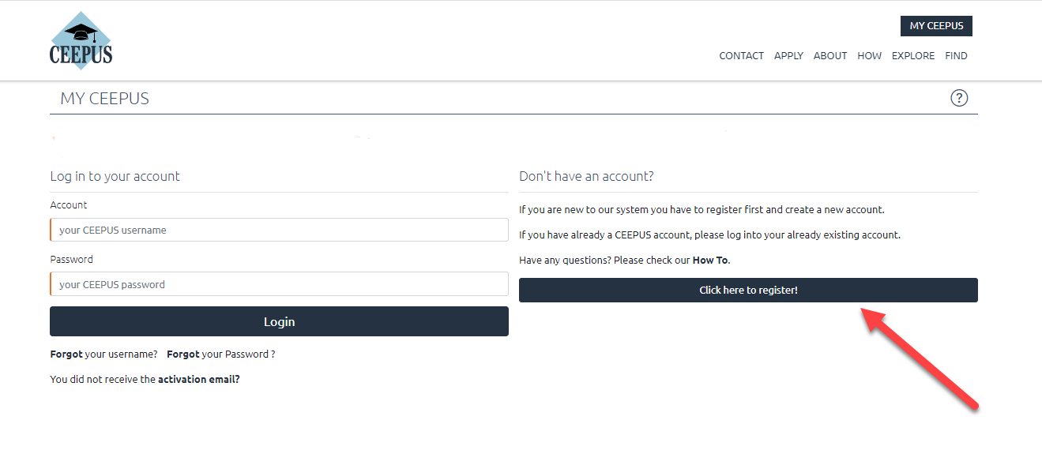In the next step please fill in the required data and click on submit
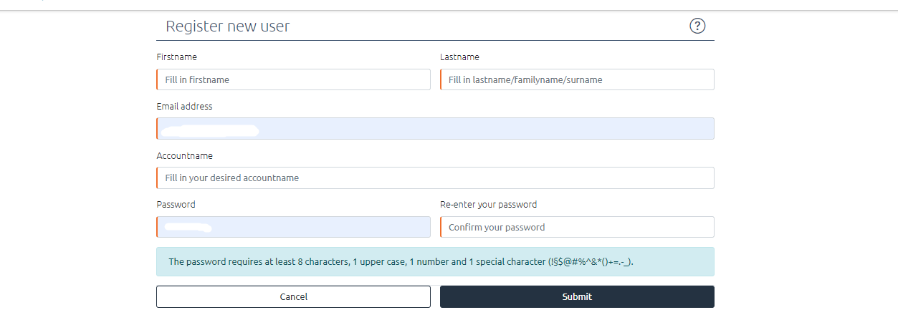

Now please check your emails, also check the spam folder. Then activate your CEEPUS account in your E-Mail.
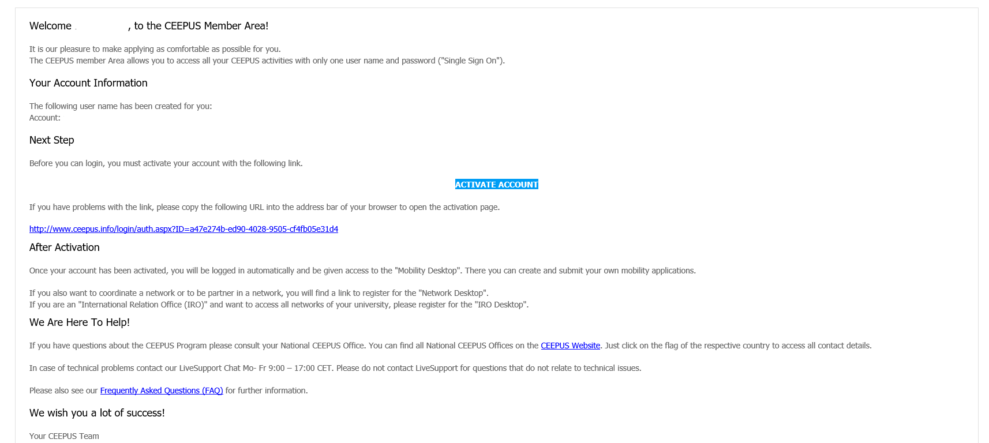

Now you have access to your CEEPUS Mobility Desktop, and you can apply/create new mobility applications.
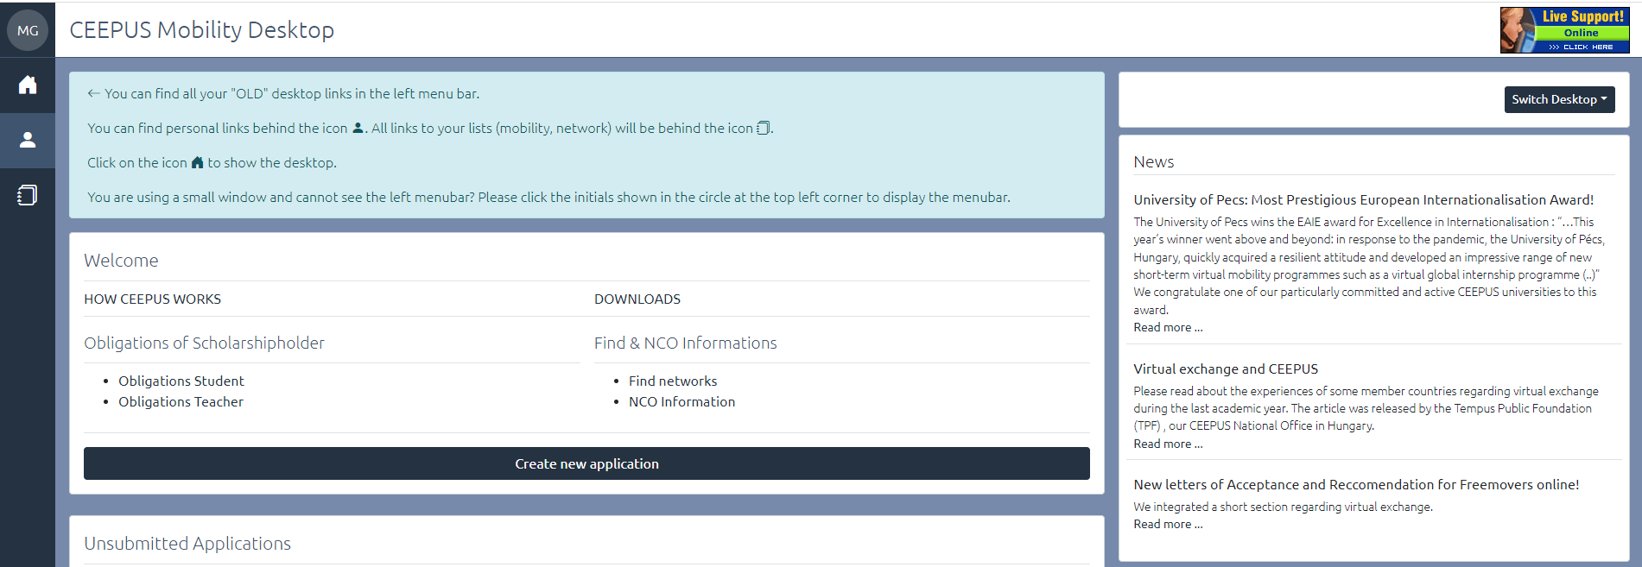

HOW TO apply for a CEEPUS Freemover grant – Ukrainian academics:
For all CEEPUS applications: You have to register and create an account under My CEEPUS first.

- After signing in: On your CEEPUS Mobility press „Create new application”:
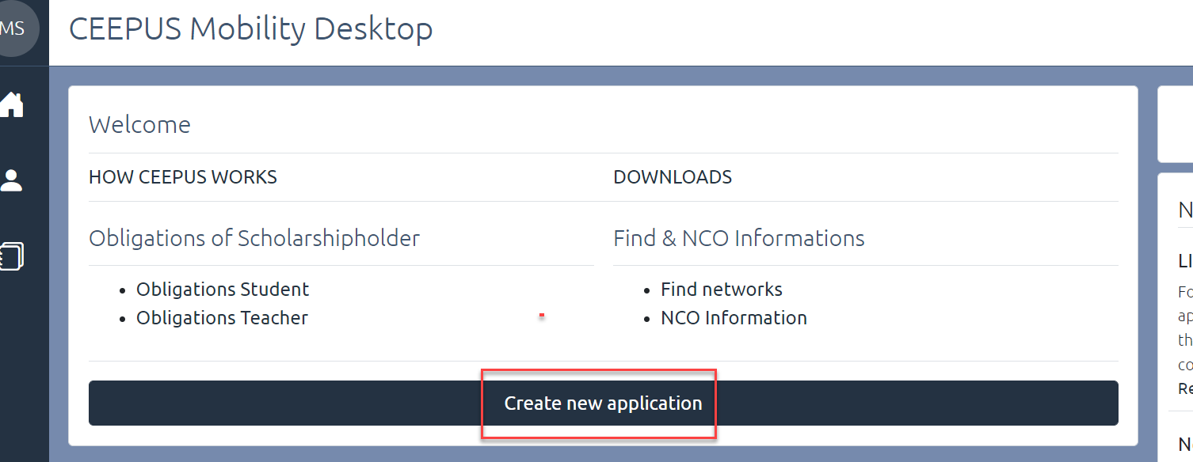

Activate “No” to apply as freemover, then press “next step”:
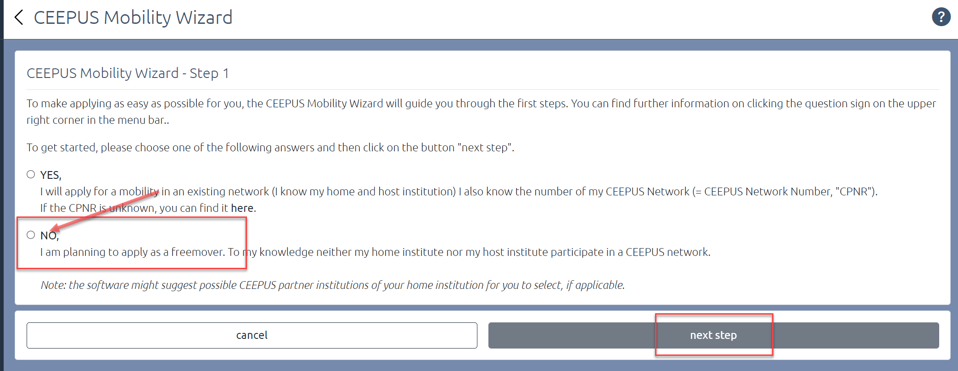

Please choose “Ukraine” as Home Country, “Ukrainian University (…)” in general as Home Institution, and “My home Unit is not on the list” under Home Unit.
Type in your Ukrainian university in the entry field.

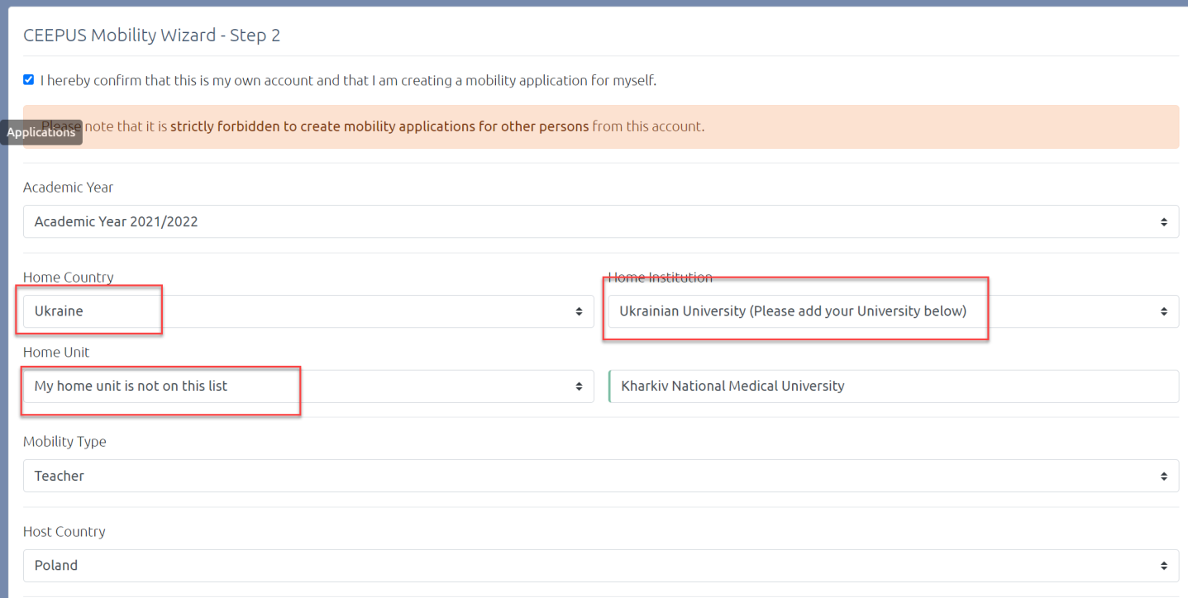

Please pick your host country and your host institution and then press “select >>”
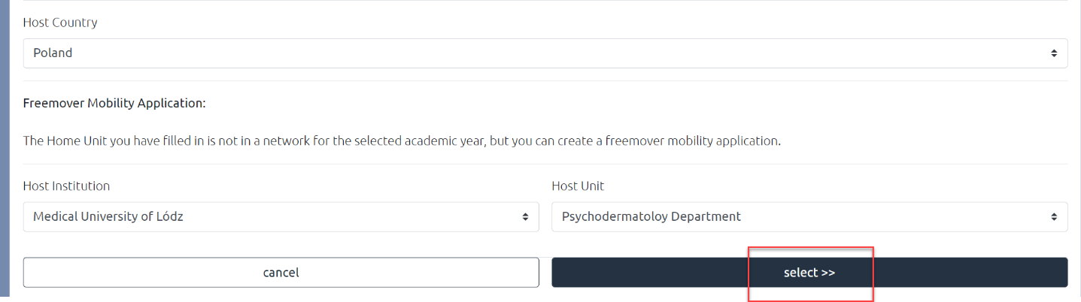

Now you see the overview of your application, with the different sections. Fill out all red marked sections.
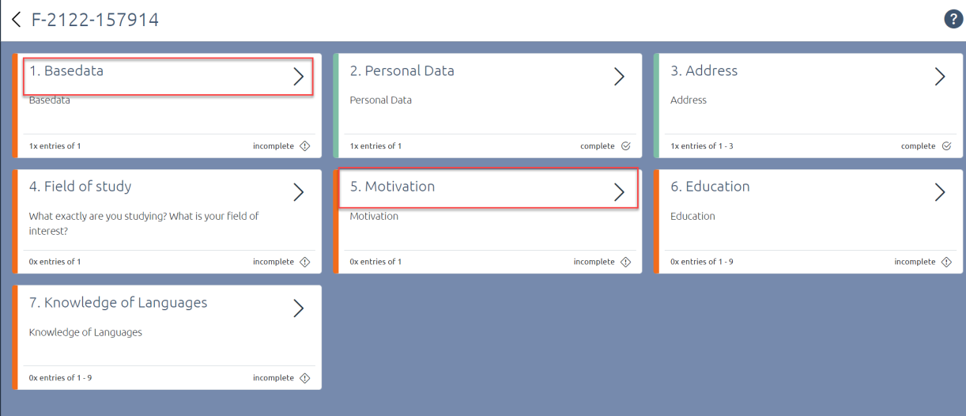

Under Basedata, you must fill in a duration of stay. Ask your contact person or our National CEEPUS Office for further advice.
You also need to upload a letter of acceptance or teacher letter from your host institution. Please access https://www.ceepus.info/content/downloads for a template.
Instead of a letter of recommendation, you should upload a confirmation of enrollment of your Ukrainian university or - as teacher - a confirmation of employment. Press “Edit Upload” to upload.
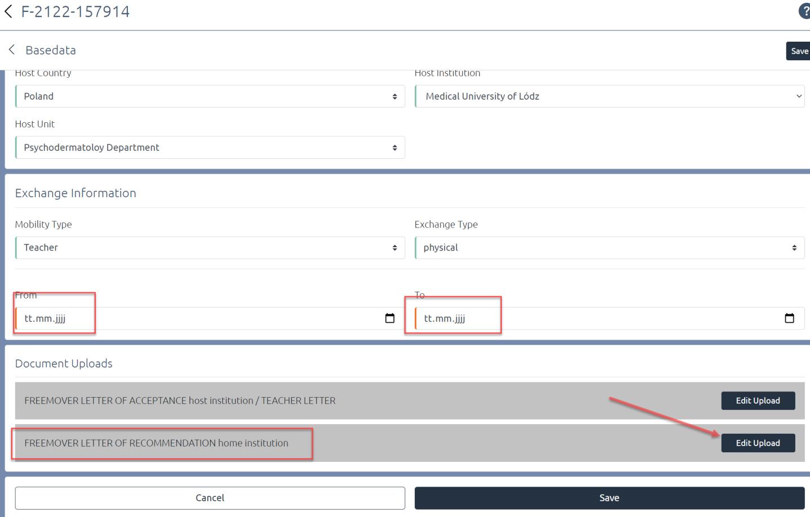
Do not forget to press “Save”.
Use the arrows to navigate.
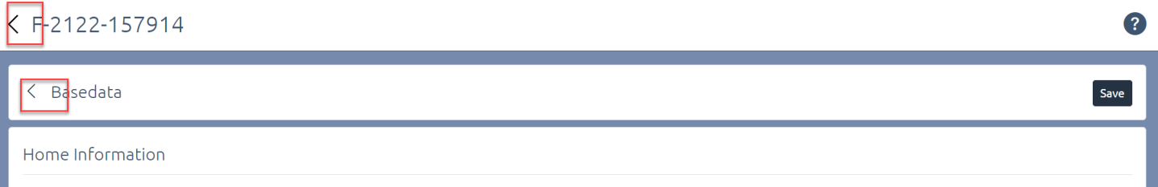

Once you have filled out all sections, navigate another step back to submit the application
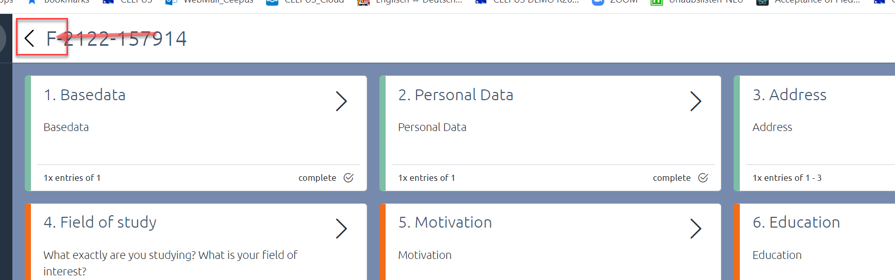

Press “submit” and confirm the workflow execution.
