AC TRADUCTORES
&
ACADEMIA CORDOBA

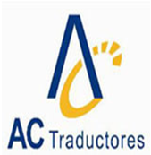
WWW.ACTRADUCTORES.COM
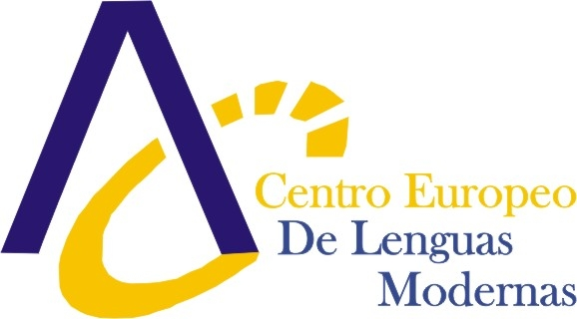
WWW.ACADEMIACORDOBA.COM

Address
CALLE HUERTAS, 122
23600 MARTOS (JAÉN)
ESPAÑA

Managing Director
Name: Hector Bernal Trujillo
Phone: 0034 953 08 08 58
Fax: 0034 953 08 08 57
Email: actraductores@actraductores.com

Contact Human Resources / Internships (Student Placements)
Name (position): Soraya Guerra Luque - Project Coordinator
Phone: 0034 953 08 08 58
Fax: 0034 953 08 08 57
Email: actraductores@actraductores.com

Preferred Fields of Studies
Tourism, Translation, Marketing and International business and commerce

Line of Industry
- Translation and Interpretation work (specialised, general, informative) and revising translations in various combinations: English – Spanish – English, Polish – Spanish - Polish
- Observing translators’ work
- Receiving the orders for translations, preparing a valuation of the commissioned translation, looking for the appropriate translators for each work between the inner translators of the company and the freelance translators
- Interpreting in combinations : English – Spanish – English, Polish – Spanish - Polish
- Observing different aspects of working as a translator and interpreter in Spain.
- Organizing the different groups and their activities
- Accompanying different groups on study visits (to Spanish companies, schools, organisations, hospital, etc.) as an interpreters assistant
- Accompanying different groups as a guide and interpreter on their cultural visits to different Spanish cities (Granada, Jaén, Malaga, Córdoba, Seville) during which the beneficiary will have the opportunity not only to improve his/her professional skills but also to see the most important Andalusia monuments and learn about the Spanish history and culture of each city
- Arranging the visits of different groups, receiving the beneficiaries themselves, supervising and monitoring European projects, as well as arranging cultural and sport activities for the groups
- Opportunities to teach English to both children and adults
- International Marketing research
- Developing and designing databases of clients and providers on a European level
- Establishing contacts with international clients in order to organize visits of English speaking beneficiaries
- Preparing and revising documents (contracts, certificates, reports) in English and Spanish
- Assisting in activities in the Department for European Projects
- Preparing Budgets and Programmes for clients
- Carrying out administrative tasks in the office, including: answering the phone, receiving clients and being in contact with Spanish and English speaking partners
- Helping in creating and reorganization of the English version of the web page of the company
- Observing the reality and conditions of Spanish labour market

How to Apply
By sending your CV with Photo to us by mail. Including a letter of expectations.

